Next JS Notes:
Backend code runs on nodeJS runtime ad frontend code gets bundled and send to client for execution within a web browser.
While working on react we need to create a separate project in a different programming language. This NodeJS runtime also allows us to render our components on server and send their content to client this technique is called server side rendering(SSR) make application faster and SEO-Friendly
We can pre-render certain pages and components that has static data when we build our application, we just render them once and serve them whenever they are needed(Static Side Generation) make application super fast.
Setup environment : nodeJS 16 or above
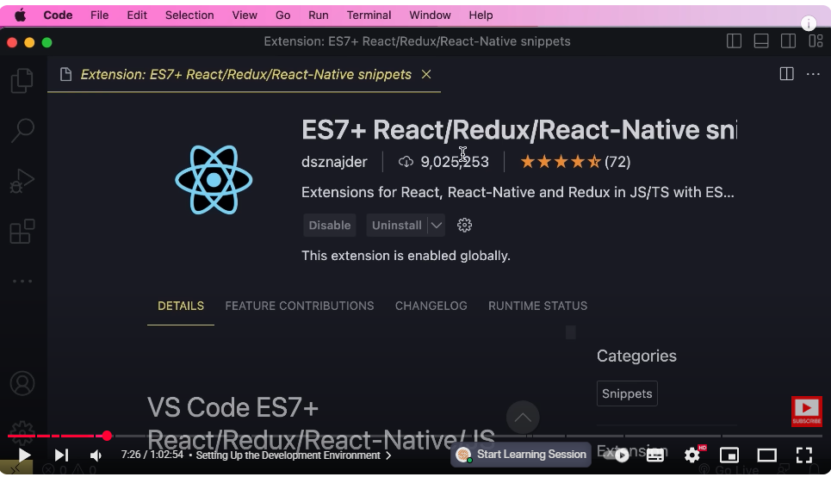
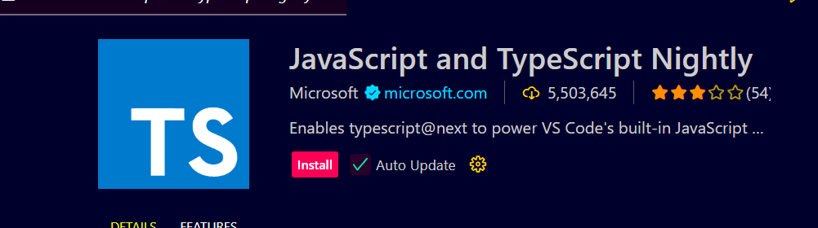
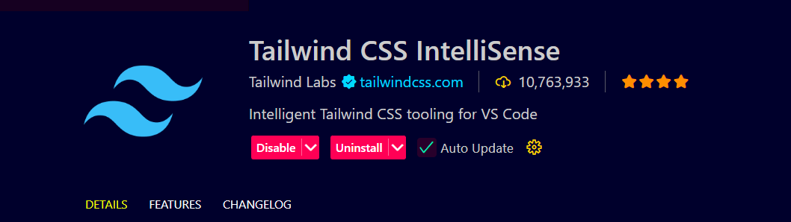
ESLint : common code analysis tool(syntax errors , formatting issues etc)
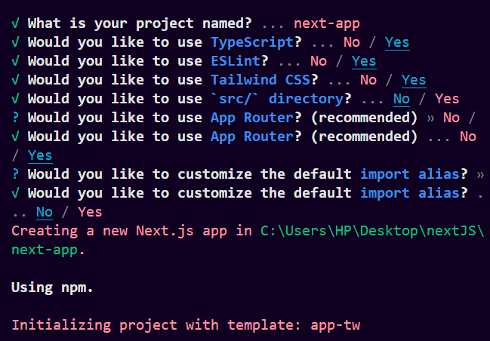
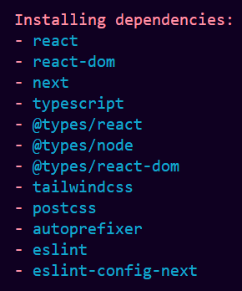
app folder:
app router based on file system , unlike react-router , we don’t have to configure our routes and map them to our components , we can simply create files or folders to represent our routes
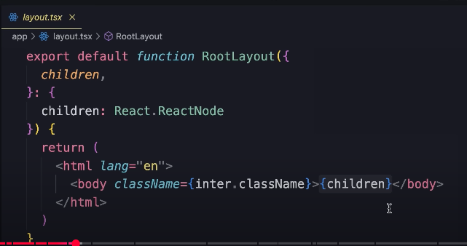
{children} will be replaced by our page dynamically at runtime depending on where the user os on the application.
Page.tsx home page
Routing and Navigation

Users folder page.tsx (routing system in NextJS is based on convention not configuration), in this page we should export a react component that will be rendered when user is at this location /users.
The name of component does not really matter in terms of routing, its just for better organization of our code
If we put any other file in users let say test.css that would not be publically accessible in app router, in page router they are accessible
Nested route
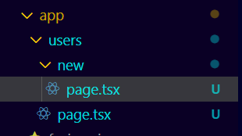
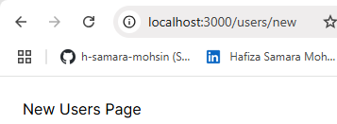
Navigation
Problem with anchor tag
When we use <a> , open devTools look in the network tab look at all requests sent to the server
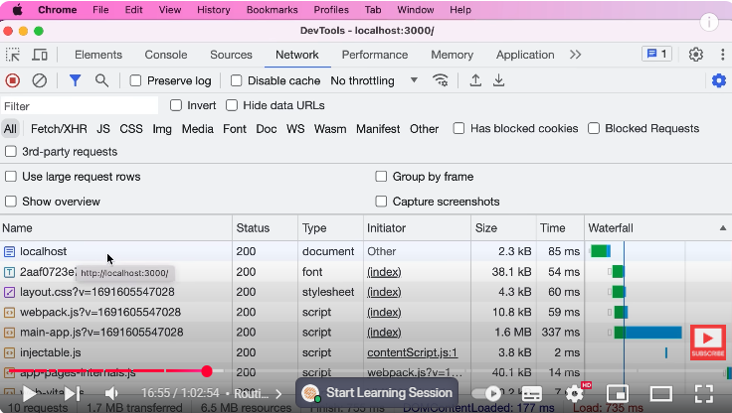
first is our HTML doc
2nd is font
3rd is CSS file
after that we have bunch of JS Files
let me clear tab
click on the route when navigation occurs all of the resources are re-downloaded, this is not optimal way , b/c in real application we probably have navigation on top,a side panel on left , as users navigate from one page to another, we don’t want to reload the repetitive part, we only want to replace content area, this is where we use Link in nextJS
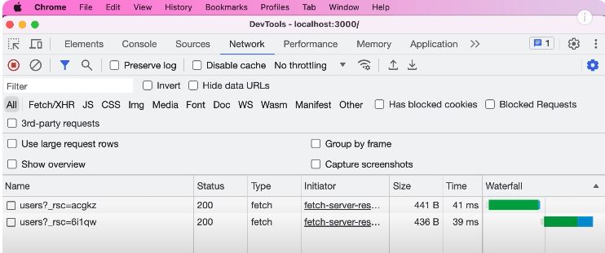
We only have 2 requests and these req are for downloading content of user pg
client side navigation
further explore …………..
Rendering Environments
In nextJS we have 2 environments where we render our components and generate HTML markup , either on client within web browser or on server within nodeJS runtime
Client side rendering , server-side rendering
large bundle size, resource intensive
In client side rendering we have to bundle all of our components and send them to client for render, this means as our application grows , so does our bundle size b/c it must contain all of our components.The larger the bundle , the more memory we need on the client now the larger the bundle the more memory we need on the client to load all these components so this approach is resource heavy
No SEO
problem is that search engine bot Parts(crawlers) which are machines that browse and index our websites can't view our content
because they can't execute JavaScript code so they cannot render our components like a web browser and last
but not least any sensitive data we have in our components or their dependencies like API keys will be exposed to the
client now
SSR
if we render our components on the server we can get rid of all these problems we only send the
essential components to the client and prevent our bundle from becoming unnecessarily large also because the
server handles most of the rendering we need less resources on the client plus because rendering is done on the server
and we send the actual content to the client search engine Bots can view and
index our pages and finally we can keep sensitive data like API keys on the
server so these are all the great benefits of server-side rendering however with server-side rendering we
SSR:
and we send the actual content to the client search engine Bots can view and
index our pages and finally we can keep sensitive data like API keys on the
server so these are all the great benefits of server-side rendering
DISADVANTAGE OF SSR:
however with server-side rendering we
lose interactivity so server components which are components that are rendered on the server cannot listen to browser
events like Click Change submit and so on they cannot access browser apis like
the local storage they cannot maintain state or use effects these functionalities are only available in
client components
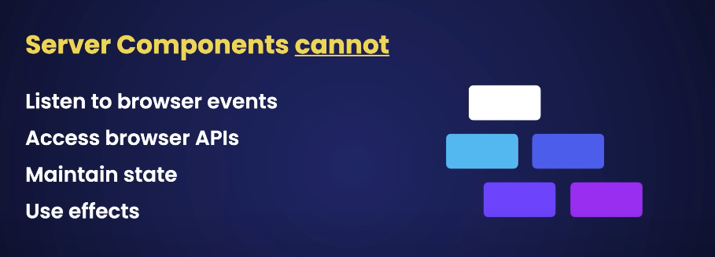
Mixture of server and client components:
so in real-world applications we often use a mixture of
server and client components we should default to server components and use client components only when we
absolutely need them here is an example let's imagine we want to build a page to show a list of products to build this
page we probably need several components like navbar sidebar product list product
card pagination and footer now in standard react applications we have to
package all these components and send them to the client for rendering but in next.js we can keep all these components
on the server and minimize the bundle size there is just one exception to add
a product to a shopping cart we need to handle the click event of a button typically we implement this
functionality in the product card component so we have to make it a client component that's one option
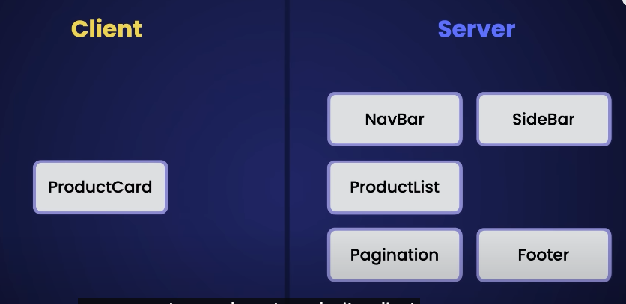
but there is
a better way we can keep this component on the server and do most of the rendering there and instead extract a
small component that only contains the add button with this change we only ship
that tiny component to the client and keep everything else on the server
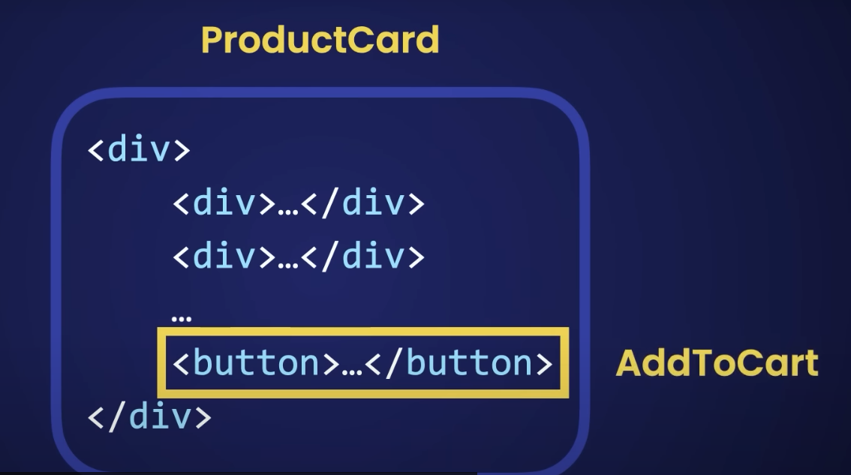
let's see this in action back to our project
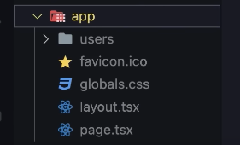
in next.js all components inside the app folder are server components by default.
so that means all the pages we have created so far these are server components and are rendered on the
server let me show you so back to the browser let's bring up the network Tab
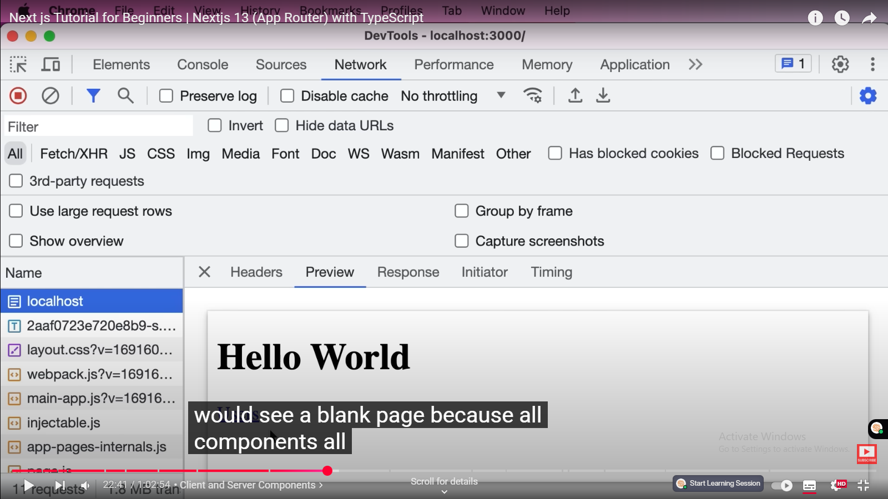
and look at the first request this is the HTML document that we get from the
backend so look we have our content here we have our hello world and the user's
link this is exactly what search engine Bots see when they browse our website in
contrast if we used client-side rendering which is how standard react applications work search engine Bots
wouldn't be able to see our content they would see a blank page because all components all the content is rendered
on the client.
okay so back to our project all components
inside the app folder are server components by default now if you have worked with nextjs before I should
mention that the pages router doesn't support server components so going forward you should stop using it and
switch to the new app router okay now let's create a new folder here
called components earlier I told you that this folder is not publicly
accessible unless we have a page file inside it so that means we can co-locate
our project files like our components and other building blocks with our Pages
we can put them next to each other and this is perfectly fine so here in the components folder let's add
a new file called Product card.tsx here we create a basic react component
now earlier I told you that server components cannot have interactivity so
they cannot handle browser events like Click Change and so on so that means if
we add a button here and handle the click event we get a
runtime error let me show you
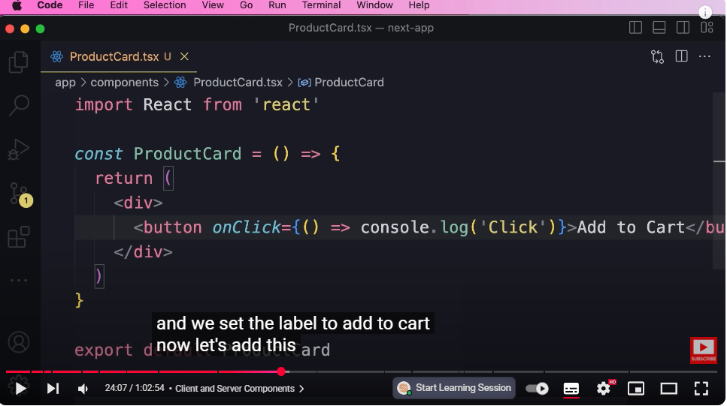
so let's pass a basic error function
and log something on the console and we set the label to add to cart
now let's add this component to our home page
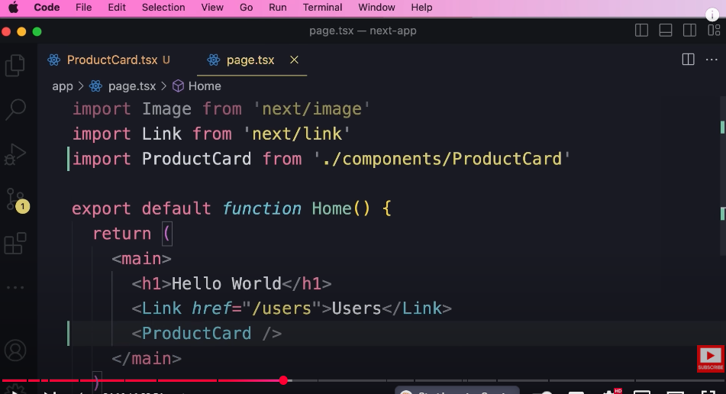
so we go to our first page file
and add our new product card component now back to the browser look we got an
error
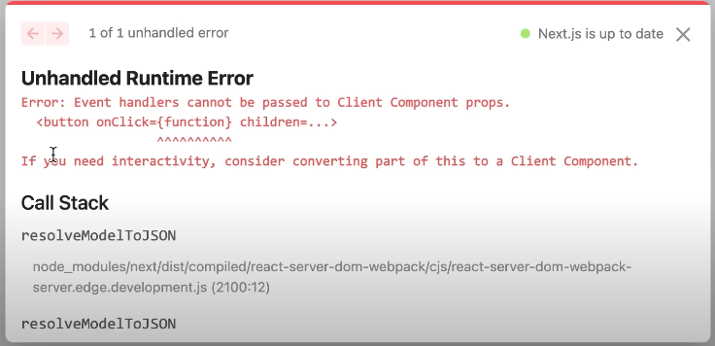
saying event handlers cannot be passed to client component props if you
need interactivity consider converting part of this to a client component now
here we have two options one option is to make this entire component a client component so we go to the top
and use the client directive so in quotes we type use client
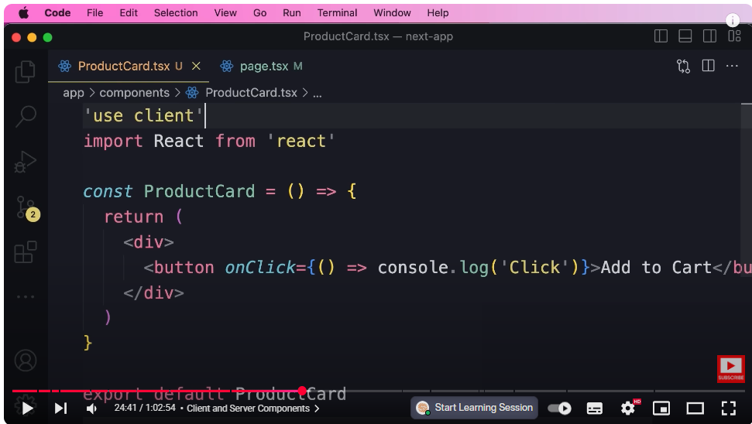
that's all we
have to do with this we tell the Nexus compiler to include this file or this
component in our JavaScript bundle and that means if this component is dependent on other components those components will automatically become client components and will be included in our JavaScript bundle so we don'thave to repeat this directive on every client component okay so here's one option now if you go back to the browserthe error is gone
but there is a better way to make our applications faster and more search engine friendly we want to render our components on the server as much as possible and use client components only when absolutely necessary
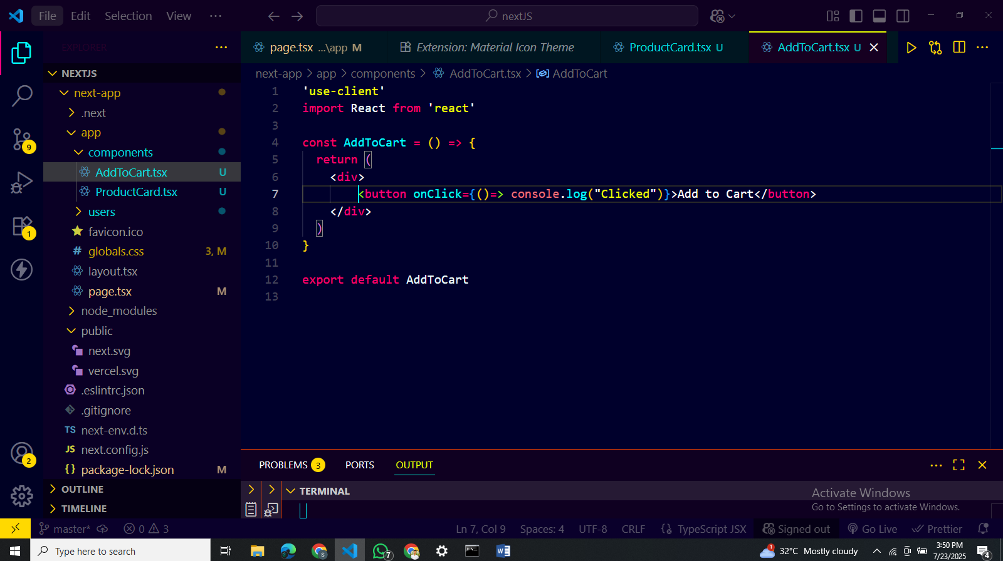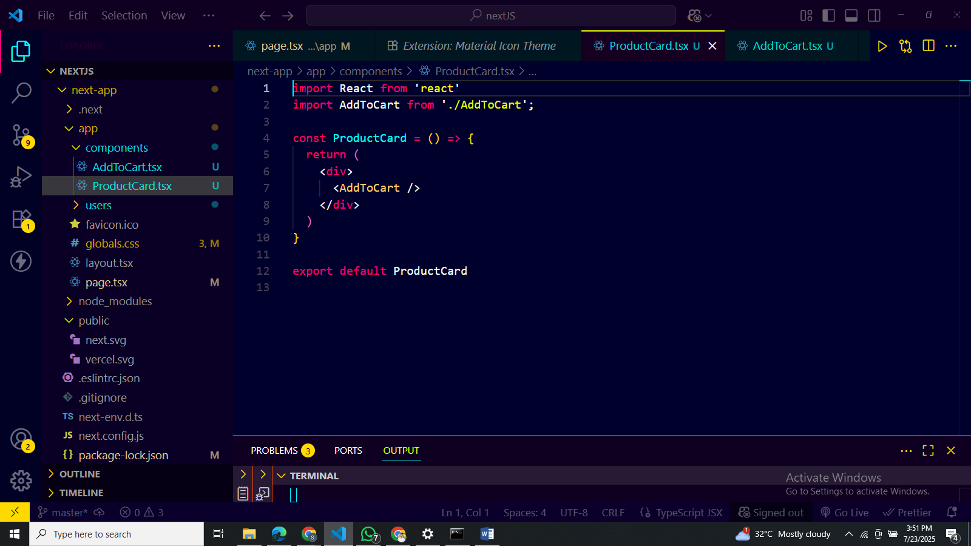
so here our product card could have some complex markup we want to render all that markup on the server and move this button to the client so I'm going to extract this button and put it inside a separate component so here in the components folder let's add a new file add to cart again we create a basic react component on the top we use the client directive and then we move this button to our new component like this okay so now we have a client component and we're going to use this in our product card okay with this we can remove use client from this file so this component will be rendered on the server and that means where we have a client component in this case where we have this button there is going to be a hole or a slot where react will later inject our client component okay now if you go back to the home page again we don't see any errors so this is
how we can create and use client and server components hey guys I hope you've been having fun
watching this tutorial I just wanted to mention that this tutorial is the first hour of my complete next JS course so
26:47
after you finish this if you want to learn more I highly recommend you to enroll in the full course because it's
26:53
much faster and easier than jumping between a bunch of random disconnected tutorials here on YouTube the full
26:59
course is 5 hours long and teaches you everything you need to build full stack applications with nexjs it also comes
27:07
with a certificate of completion and a 30-day money-back guarantee so if you're not happy ask for a full refund you get
27:14
all your money back no questions asked in case you are interested the link is below this video.
Data Fetching
now there are two ways we can fetch data we can fetch it on the client or on the server
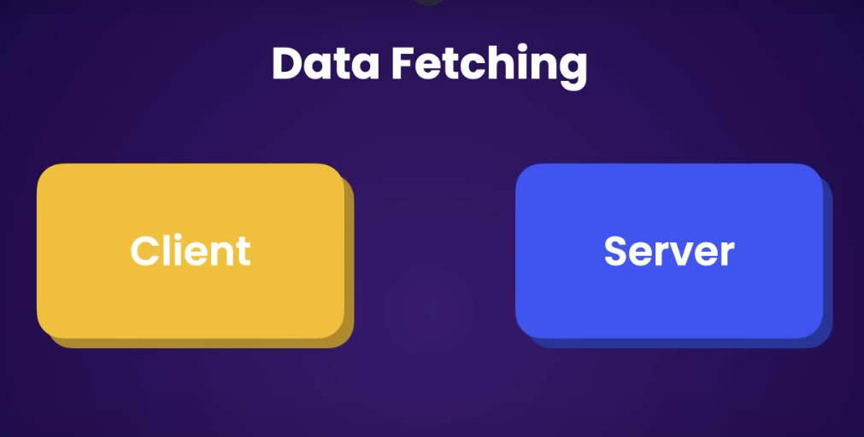
To fetch data on the client we typically use the state hook to declare a state variable and the effect hook to call the back end get the data and put into our state variable now in my react course I talked about react query as a better alternative to manually using the state and effect hooks but regardless of how we fetch data fetching data on the client in client components has all the problems we talked about in the previous lesson
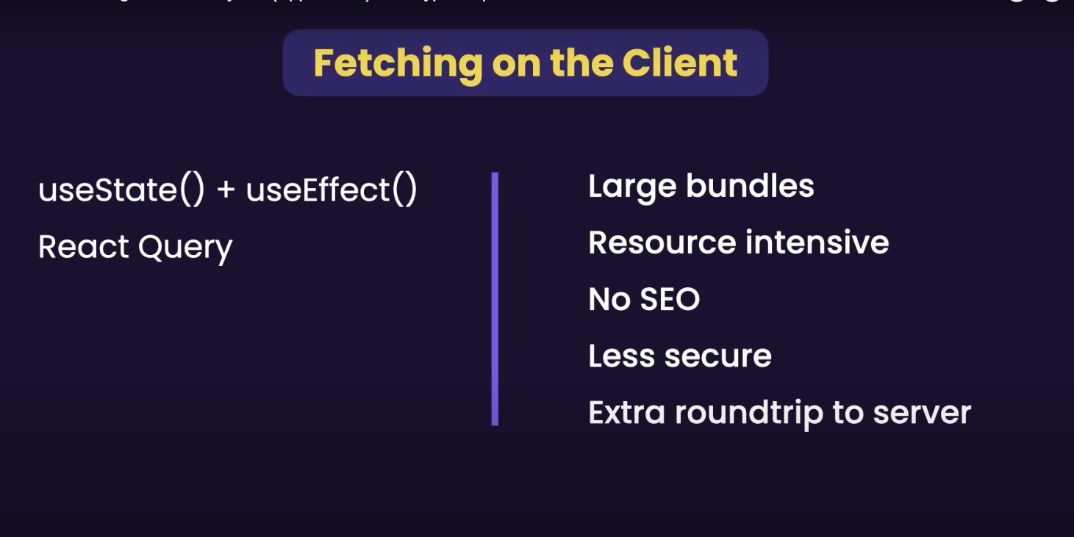
so over time our bundles would get larger because we have to ship more and more components to the client also this approach is resource intensive because all the rendering is done on the client plus our content or our data is not visible to search engines and this approach is less secure because our API keys or any kind of sensitive data will end up on the client but there is one extra a problem the problem is that with this approach there is always an extra round trip to the back end so when a react application loads first the browser downloads the HTML template as well as the CSS and JavaScript files from the backend then it will send an extra request to fetch data from the backend so there's always an extra round trip to the backend
now we can fetch data in our server components and get rid of all these problems let me show you in this lesson we're going to use Json placeholder to get some dummy data into our application
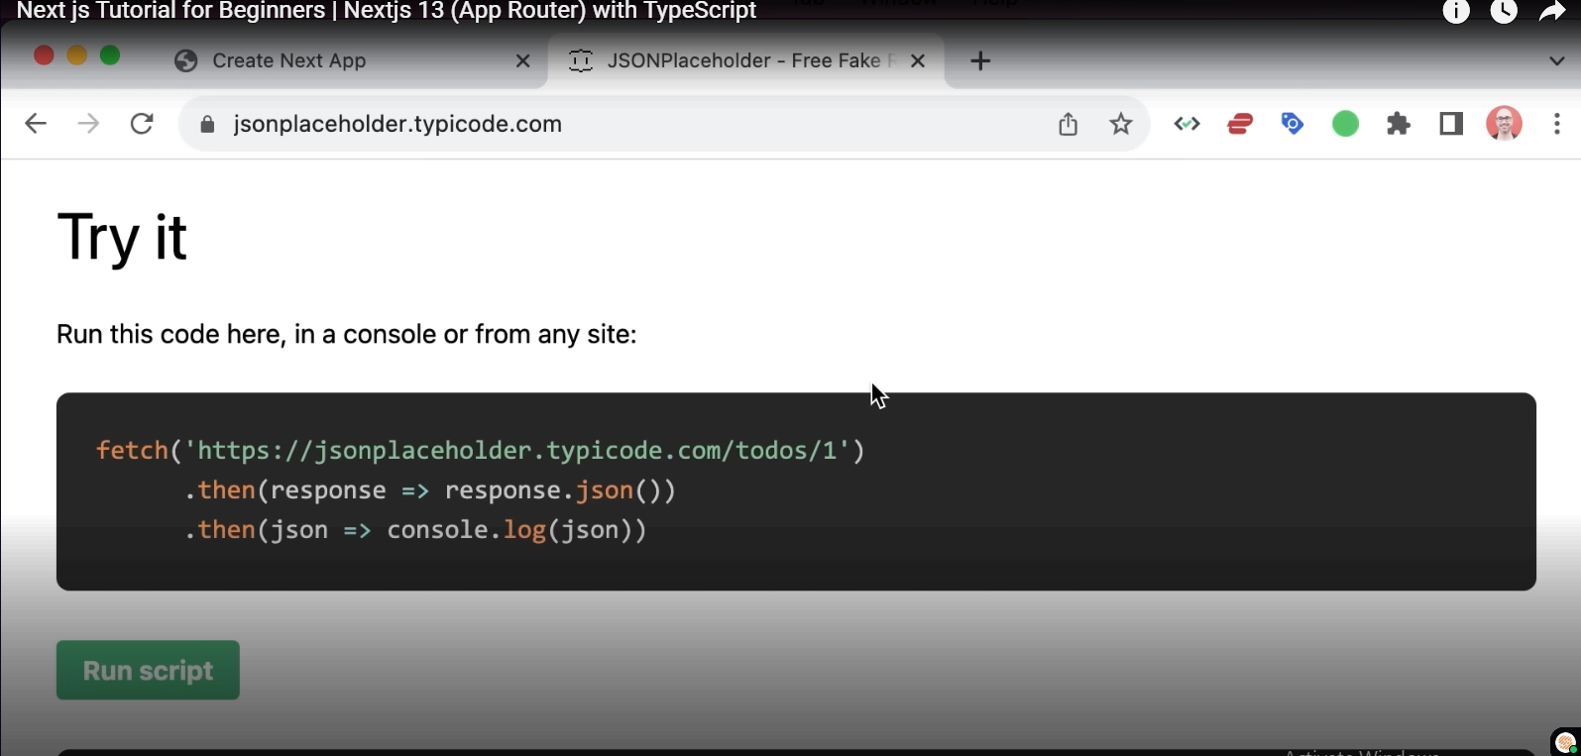
in case you are not familiar with Json placeholder it's a fake API for getting some dummy data so head over to jsonplaceholder.typeyoucode.com on this page you will find various endpoints for getting dummy data like a list of posts comments albums photos to-do's and users in this lesson we're going to get a list of users into our application so look each user object has a bunch of properties like ID name username and so on so back to our project let's go to the app folder and then open the users folder and then go to this page now this is a server component and in server components we can use the fetch
function that you're probably familiar with this function is defined in browsers and with this we can send HTTP requests to a
backend so here we pass the URL of our endpoint which we grab from here so copy and
paste it now this returns a promise so we have to await it to get the response now because we are
using ubaid here we have to make this component async now this is the beauty of this approach
with this approach we don't have to use a state variable we don't have to use the effect hook with zero dependencies
there's no ceremony we just call fetch to get the data and all of this happens on the server you will see that in a minute so we get the response then we call response.json this also returns a promise so we'll rate it to get the data in this case our users next we map these users to a bunch of list items exactly like how we render them in a react application so for our markup let's replace this div with a fragment here we add an H1 called users then we add an unordered list and here we map these users we grab each user now if you type user dot look we don't see anything because the compiler doesn't know about the type of these user objects so if you hover our Mouse over this constant look the type of this constant is any which means we don't know it could be anything this is where we can use some typescript magic to improve our code so outside of this component we Define an interface or a type called user and here we say that each user has a property called ID of type number it also has name of type string and so on we could list all the properties we have here but that is not necessary for this lesson so we're going to keep things simple so with this interface we're defining the shape of our user objects
okay now where we declare this constant we annotate it with its type which is user array okay with this when we type user Dot we can see the properties of user objects so this is the benefit of using typescript with typescript we get all the completion when we are coding and also if you have any kind of Errors like typos we can cache those errors at build time before we run and deploy our application okay so here we're going to map each user to a list item first we give it a key which we set to user.id and here we render user.name that's all we had to do so our code is simpler there is no State and effect hook here our bundle is going to be smaller because this component will be on the server now back to the browser let's go to the users page here's our users beautiful now let's bring up the network tab and refresh the page so take a look at the document that we received from the backend so all our users are rendered right here this is because rendering is happening on the server
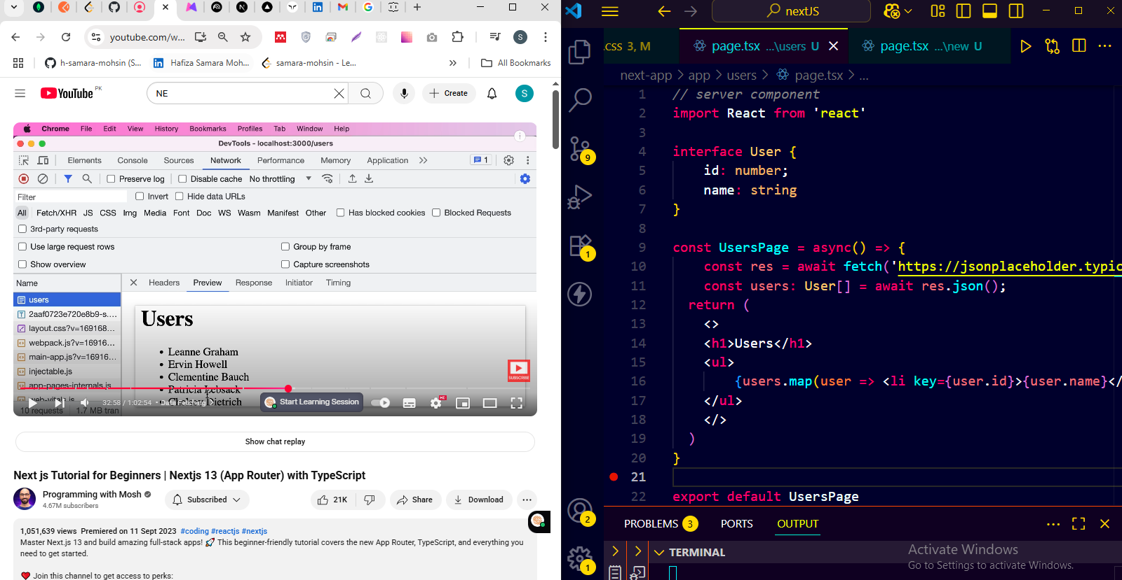
in contrast in typical react applications or wherever
33:02
we use client-side rendering the browser initially gets a blank document then it
33:07
will call the backend to fetch the data and then render the content so there's always an extra round trip to the back
33:14
end and our application is not search engine friendly so to fetch data whenever possible we should fetch it in
33:21
server components [Music]
Caching:

fetching in server components has an extra benefit and that is caching what
33:34
is caching well the idea of caching is to store data somewhere that is faster to access basically there are three
33:41
places where we can get the data from we can get it from the memory from the file system or from the network now as we go

33:49
down this list getting data becomes slower for example getting data from the network is always slower than getting it
33:56
from the file system for this reason nexjs comes with a built-in data cache
34:02
so whenever we use the fetch function to get some data next.js will automatically
34:07
store the result in its data cache which is based on the file system so the next time we need the same piece of data the
34:15
next time we hit the same URL next.js is not going to go to Json placeholder it's
34:20
going to get the data from its data cache from the file system of course we have full control over this caching
34:26
Behavior if you have data that changes frequently we can disable caching or treat data in Cache as fresh for a
34:34
certain period of time let me show you
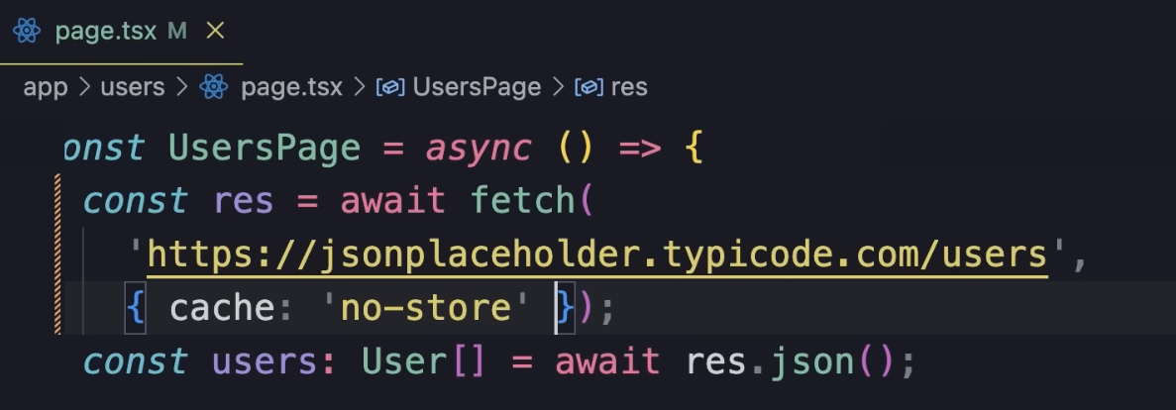
so here when we call the fetch function we can pass a second argument which is
an options object let me put this on a new line so we can see clearly
in this object we can set cache to no store to disable caching that's one option and
this is useful if you have data that changes frequently in those situations we always want to show fresh data to our
users right the other option is to keep data fresh for a certain period of time
to do that instead of sending cash to no store
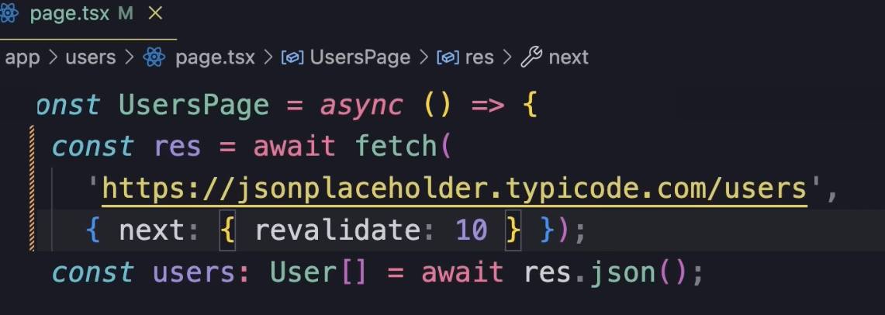
we set next to an object in this object we can specify configuration parameters that are specific to nexjs so here we can set
revalidate to Value like 10 and this means next.js is going to run a
background job and get fresh data from the backend every 10 seconds so this is
how caching Works in next.js now one thing you need to know is that this caching behavior is only implemented in the fetch function so if you use a third-party Library like axios you're not going to get this you're not going to get the data cache [Music]
Static and Dynamic Rendering
in next ways we have another performance optimization technique called Static
35:59
rendering or static site generation the idea of static rendering is that if you have Pages or components that have
36:06
static data we can have an xjs render them once when we build our application for production so next time those pages
36:13
or components are needed next.js is not going to re-render them it's going to get their payload or content from its
36:21
cache which is based on the file system this is static rendering meaning rendering at build time in comparison we
36:28
have Dynamic rendering which happens at request time let's see this in action so back to our users page let's add a
36:36
timestamp above the list of users so here we add a paragraph and render
36:42
first we create a new data object and then call to Locale time string with
36:48
this we can see when this page was rendered now back in the browser let's refresh a few times so look the
36:55
timestamp is changing this only happens in development mode but if you build this application for production you will
37:02
see that the timestamp is not going to change because next.js will treat this page as a static page and here's the
37:09
reason earlier I told you that by default whenever we use the fetch function next.js will cache the data so
37:17
it treats our data as static or unchanging data so when rendering this page next.js is that this page has
37:24
static data so it decides to render this page statically at build time but if we
37:30
disable caching next.js thinks the data on this page is going to change so it's not going to render this page statically
37:37
it's going to render it at request time to see this action let's go back to the
37:42
terminal window stop this process now earlier we used npm run Dev to start
37:48
this application in our development server now to build this for production we run npm run build

37:58
alright here you can see all the routes that are generated when we build our application for production
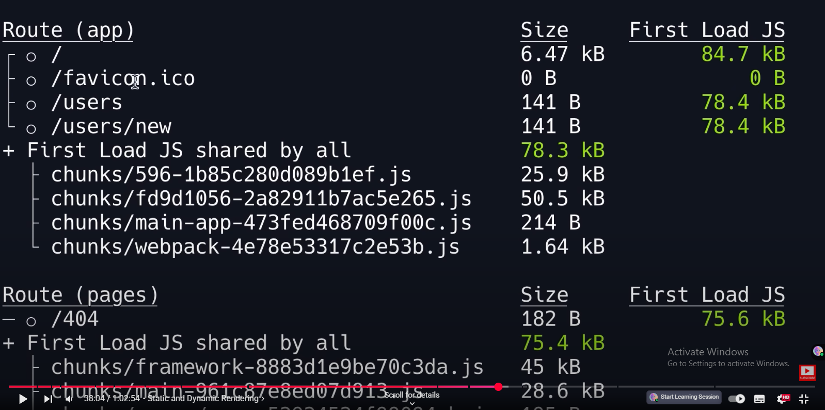
38:04
so this is our root route or the home page we have a route for our favorite icon we have one for the users page
38:11
another for the users Slash new page and so on now look at the icon before each
38:16
of these routes here we only see circles now down here you can see that a circle
38:21
means static so these pages are automatically rendered as static HTML
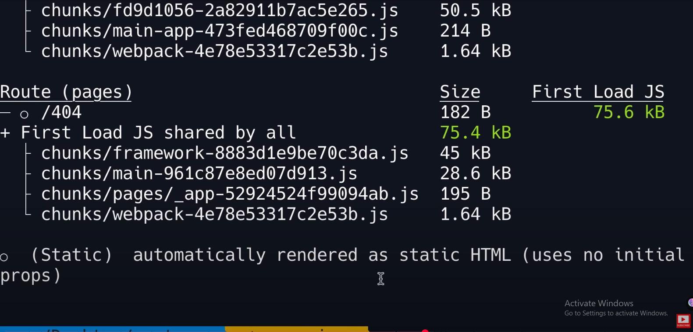
38:27
now if you start this application in production which we can do by running npm start
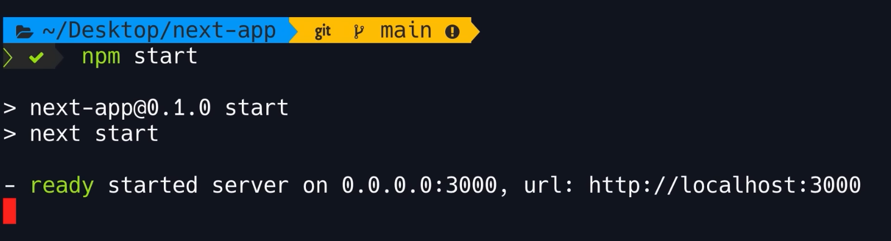
38:34
and then go back to the browser let's refresh look the timestamp is not
38:39
changing because this page was rendered statically at build time
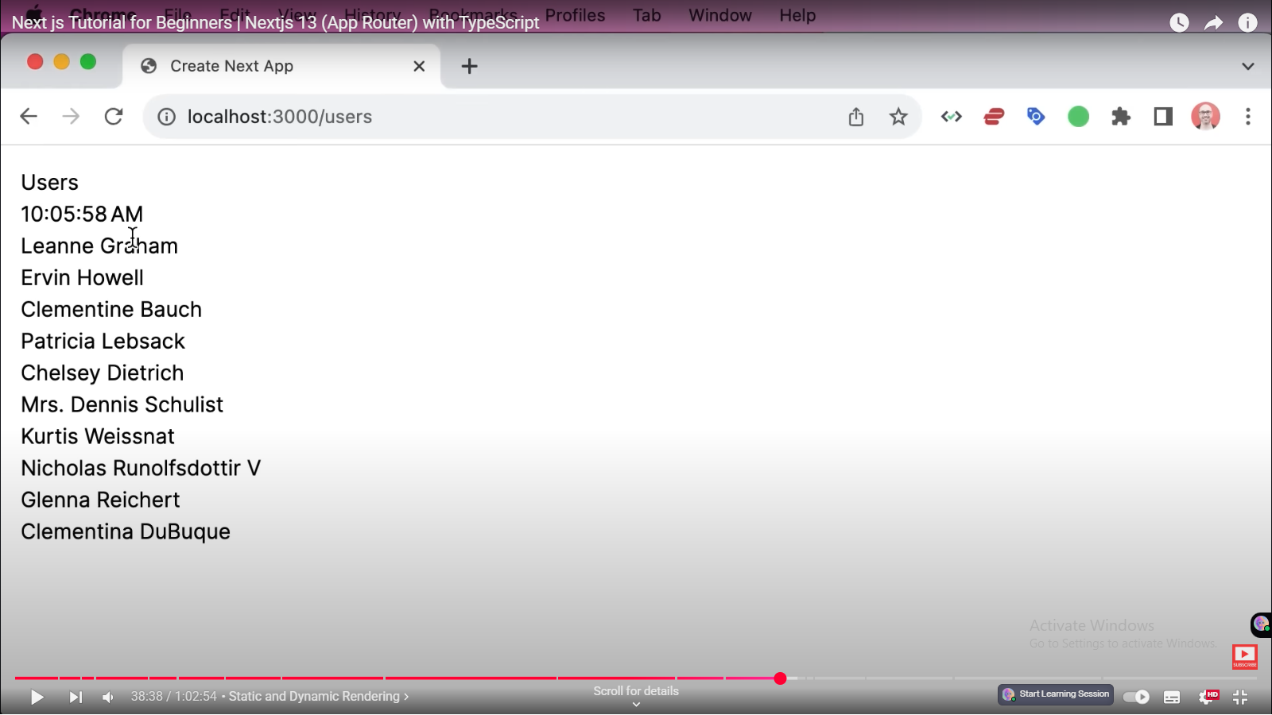
now back to this page let's disable
38:45
caching and rebuild this application for production so as a second argument we pass an
38:51
options object and here we set cache to no store
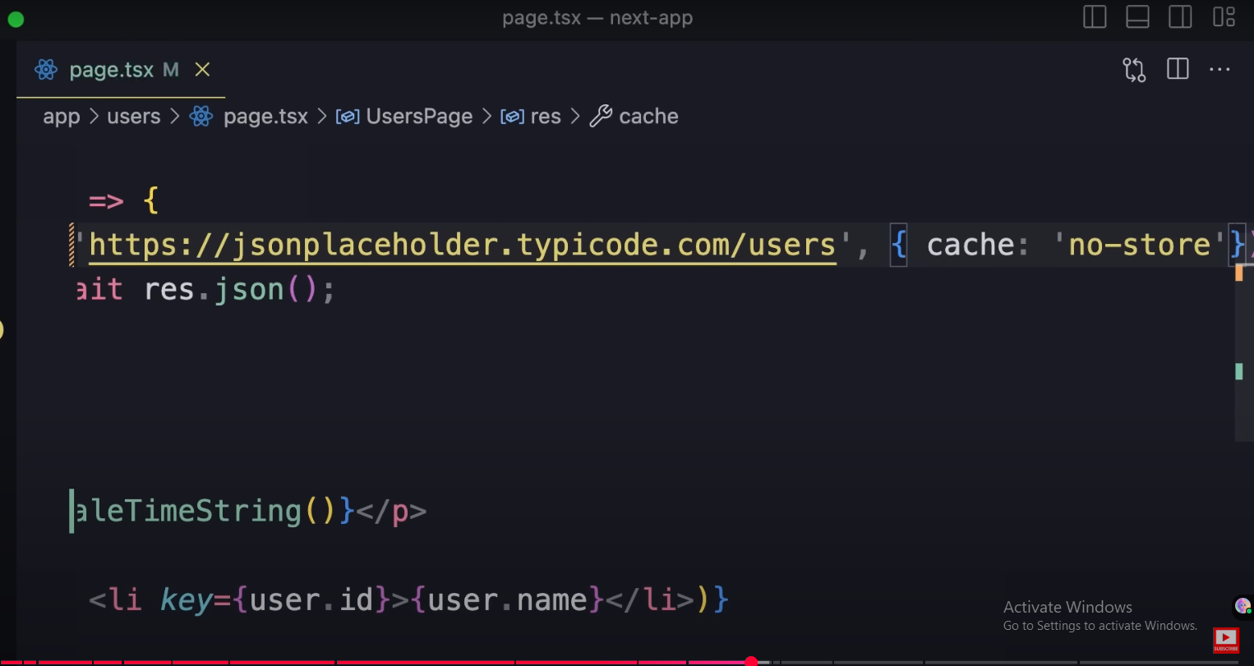
okay now back to the terminal let's stop
38:59
this process and rebuild the application
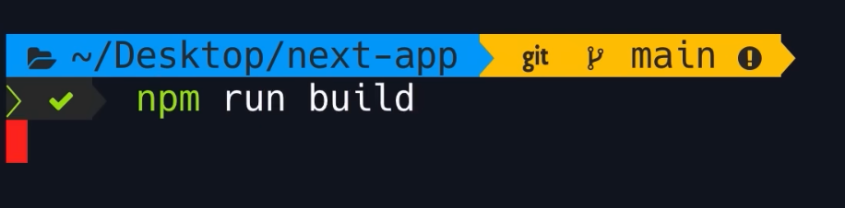
39:06
lovely now look at the icon before the user's route instead of a
39:12
circle we have a Lambda
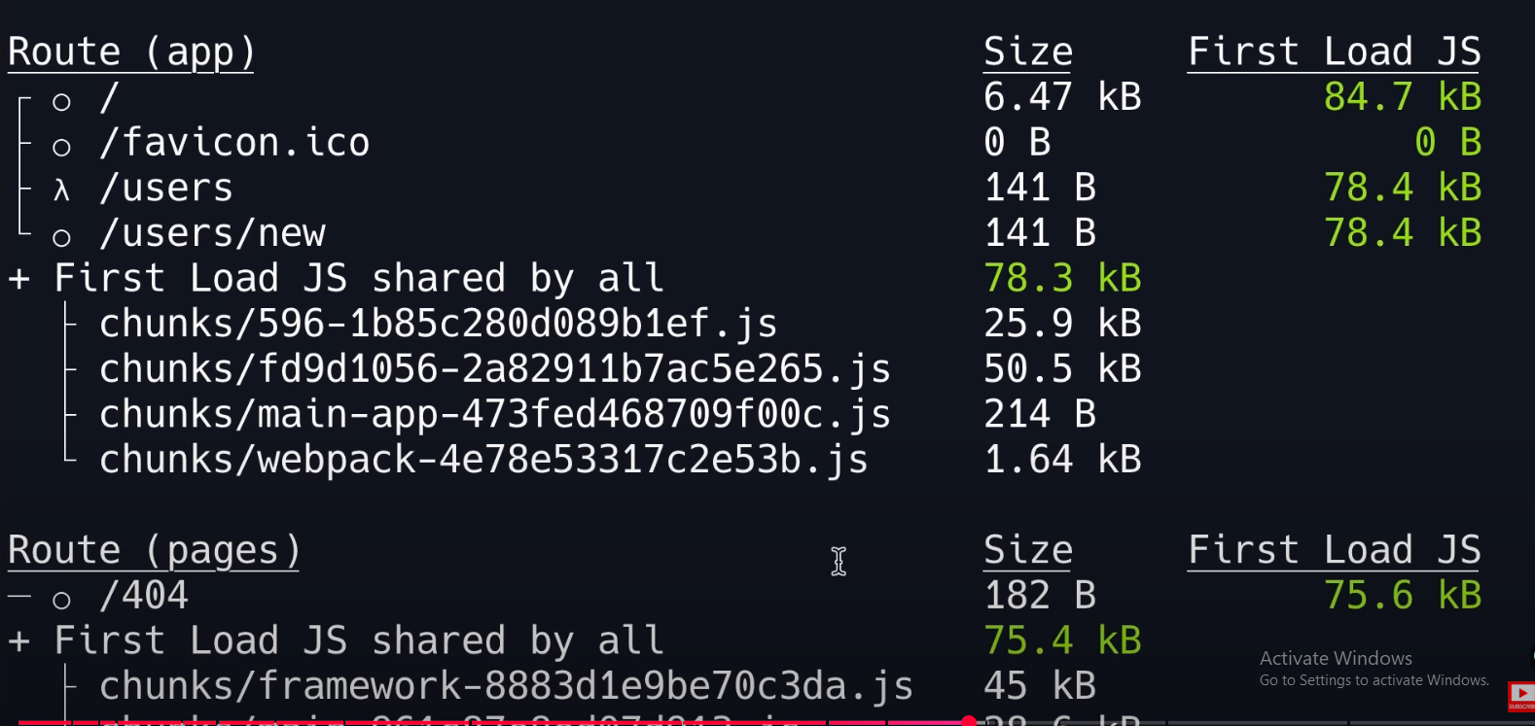
and down here you can see that Lambda means rendering
39:17
on the server
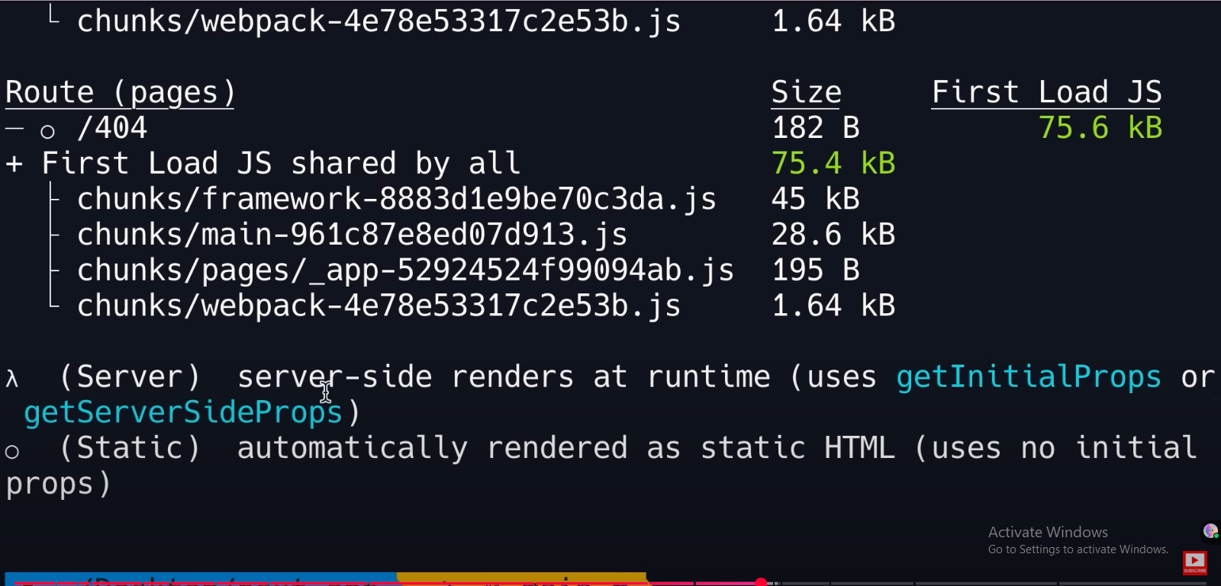
so server side renders at runtime now let's start the application in
39:23
Production

back to the browser let's refresh now look every time we refresh the timestamp
39:30
changes
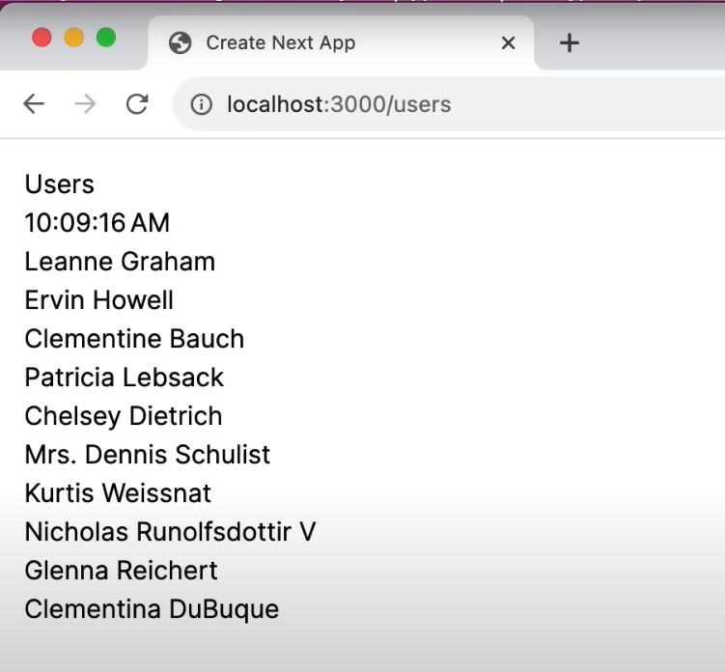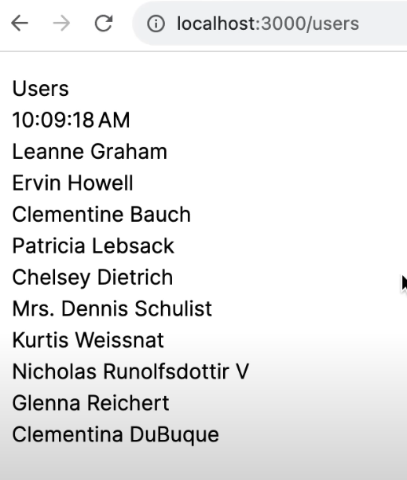

let's recap everything I've learned about rendering in next.js rendering can happen on the client or on
39:38
the server if it happens on the server it can happen at build time which is called Static rendering or at request
39:45
time which is called Dynamic rendering
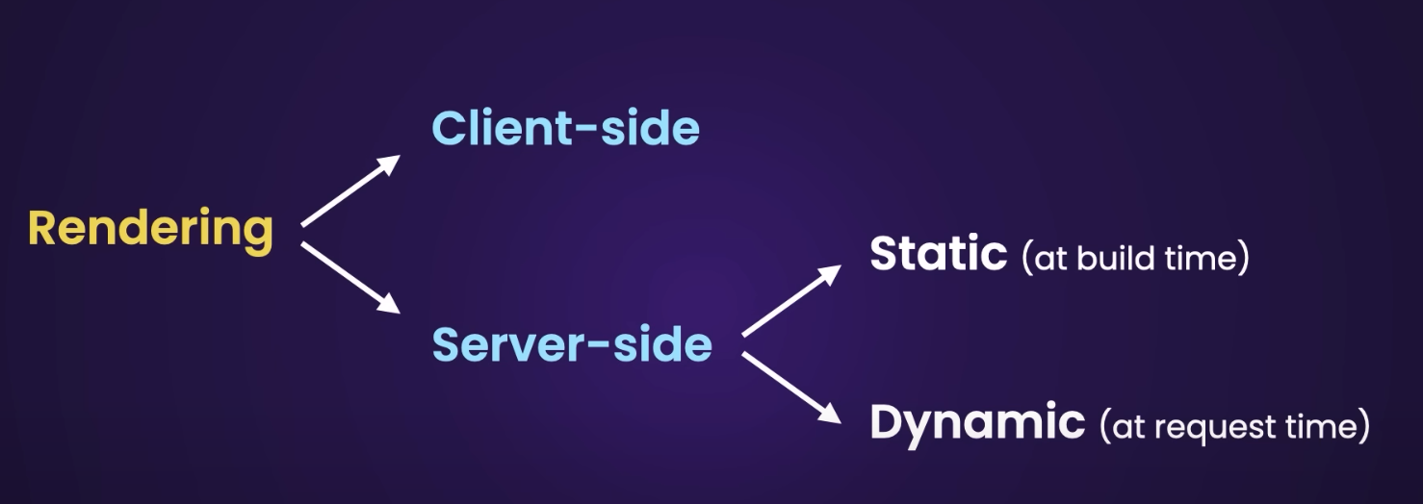
so that brings us to the end of this section in the next section we'll talk
about styling next.js applications so I will see you there

styling next.js applications

Global Styles
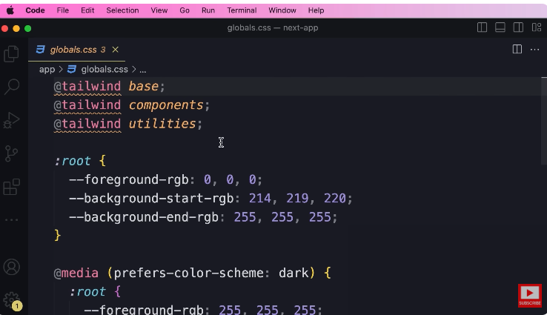
earlier in the course we briefly talked about our Global style shade in the app folder so let's open up globals.css
in this file on the top we have three directives to import the base styles from Tailwind now we're going to talk
about Tailwind later in this section but very briefly Tailwind is a very popular CSS framework okay
then after that we have this root selector this is where we typically Define custom properties like foreground
RGB and so on then
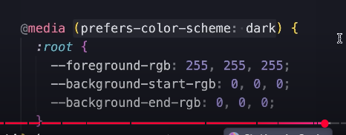
we have media prefers color scheme
dark with the CSS feature which is relatively new we can detect if the user is in the dark mode or not if so you can see that the value of this custom properties is overwritten now down here you can see that
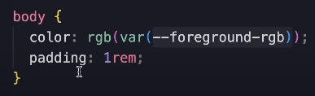
we have used the value of this custom property as the color of the body element so we are not using background start and end RGB they were used earlier when we had a
gradient on our home page so before going further let's do a bit of cleanup here I'm going to delete these two lines
and these two lines from here
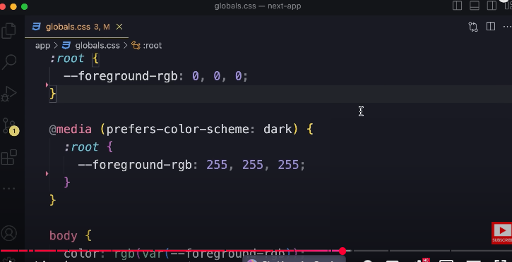
and also let's go back to the terminal
and make sure that we are running this application in development so anytime we make any
changes here we can see the changes immediately so npm run Def
good now back to this file so this is our Global style shade and we
should use it for styles that are truly Global in our application styles that apply to all pages like anything to do
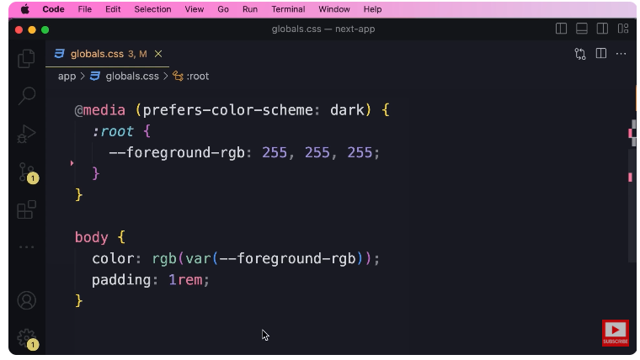
with the body element are headings our hyperlinks and so on anything that is specific to a page or a component we
should implement it somewhere else so one thing you shouldn't do here is you shouldn't Define custom classes like
user list because this only applies to a particular component or a page with this
approach as we build more and more components This Global style sheet grows really large and becomes unmaintainable
and more importantly as we change or delete our components we'll have to remember to come back and do some
cleanup here otherwise over time we'll have a lot of depth Styles in this file if you have been working with CSS for a
while you know what I'm talking about so Reserve this file for styles that are truly Global for styles that are
specific to a page or a component use CSS modules or Tailwind which we're going to talk about next
CSS Modules
all right let's talk about CSS modules a CSS module is a CSS file that is scoped
43:02
to a page or a component it's a way to prevent styles from clashing or

overwriting each other if you have been working with CSS for a while you know that if you have the same class defined
in two different places in two different style sheets these classes can override each other
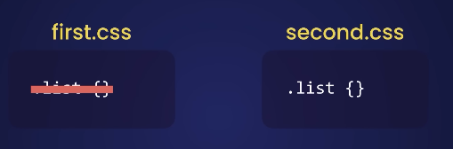
depending on how we import
these stylesheet files CSS modules aim to solve that problem let's see how they
work so here in the components folder we have a component called Product cart now
let's say we want to create some styles for this component so here we add a new file
43:38
we can call this file anything but it's better to call it the same as the component so product card what matters
43:45
is that the extension has to be dot module dot CSS okay now in this file or
43:53
in this CSS module we can Define classes that are scoped to our product card
43:58
component so let's define a class called card and of course we can Define this class
44:04
somewhere else without worrying that these classes would Clash okay so here we can apply a padding of one
44:11
ram and a border of one pixel solid CCC
44:18
now we go back to our component and import this time sheet so we type import styles
44:26
from current folder product card dot module.css the name we
44:33
assign here doesn't matter but typically we go with Styles and this will be a JavaScript object so the classes that we
44:40
Define in the CSS module will end up being properties of that object
44:45
so here if we type styles we should see those properties but I don't know why
44:51
intellisense is not currently working for me so I apologize for that so here we should see the classes we have
44:56
defined like card and so on and that means in CSS modules we cannot use
45:02
hyphens when naming these classes like card container because this is not a
45:08
valid name for a JavaScript property so in these files always use the camel case
45:13
Notation
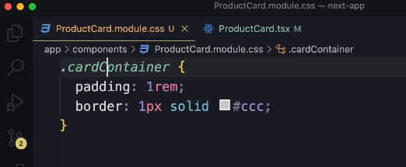
so we remove the hyphen and make the first letter of the second word uppercase okay
45:20
now let's just simplify things we go with card back to our component
45:26
so we have this object now on this div we set class name to
45:32
use our curly braces and set it to Styles Dot card now back to the browser
45:40
here on the home page we can see the style applied to our cart but let me show you something interesting let's
45:46
right click here and inspect this in Chrome devtools here's our div look at the class name
45:53
this is not the class that we created right this is auto generated so what is happening here is that this project uses
46:00
a tool called post CSS for Transforming Our CSS class names so back to our
46:06
project here in the root folder we have a file called post CSS dot config.js
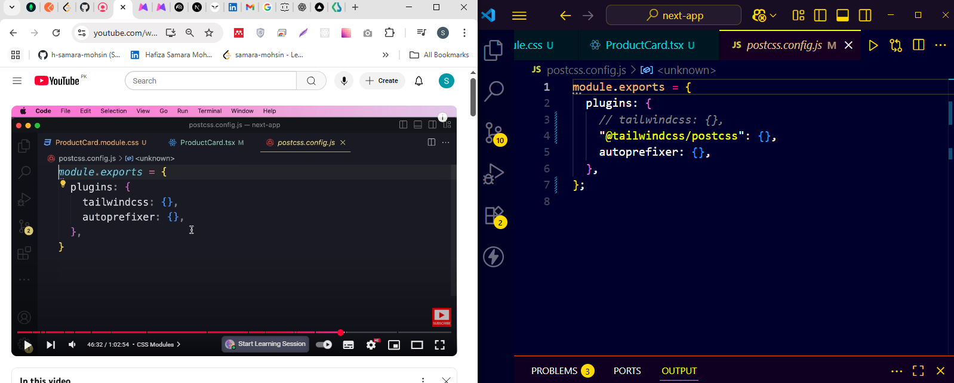
in this
46:15
file currently we have two plugins one is Tailwind the other is auto prefixer
46:20
now for the most part we don't have to touch this configuration file but if you're an advanced post CSS user you
46:26
know this is where you can provide your custom configuration so when building our application next.js
46:32
uses post CSS to transform our class names and generate unique class names
46:38
that don't Clash this is how CSS modules work now one last thing before we finish
46:44
this lesson currently I put the CSS file and the typescript file
46:49
next to each other if you don't like mixing up your CSS and TSX files you can group them in folders so here we can
46:56
create a folder like product card this is a container for our component in
47:03
this component we can have a TSX file and a CSS file okay and of course we can use the same
47:09
technique with our pages so we can use CSS modules to Define styles that are
47:15
local to a particular page [Music].
Tailwind CSS
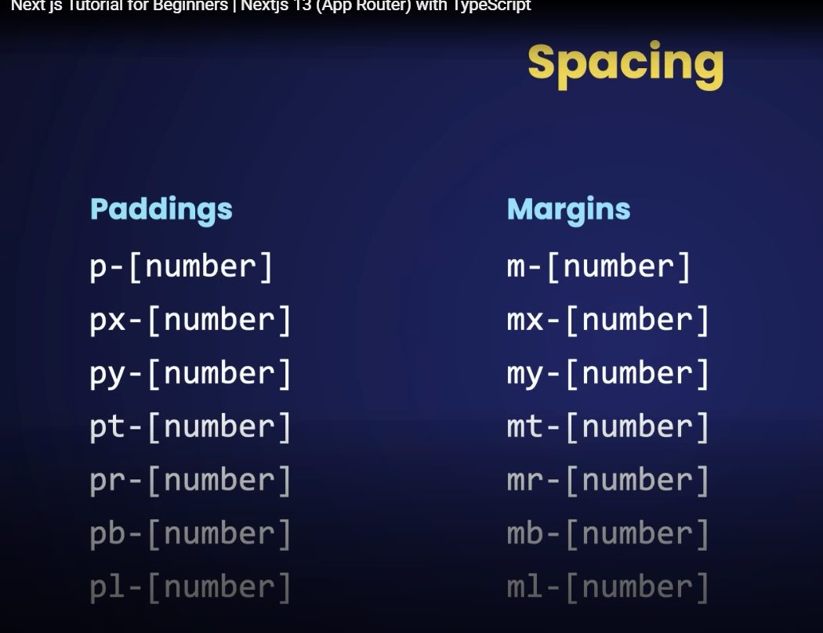
Tailwind CSS
47:23
all right let's talk about Tailwind so Tailwind is a very popular CSS framework
47:28
that uses the concept of utility classes so here on tailwindcss.com you can see that we have
47:35
a bunch of classes like Flex pt-4 which is short for padding top 4
47:41
text Center and so on so here we have a ton of small utility classes and we can
47:47
combine them to style our application some people love it some people hate it I have to convince that I also have a
47:53
love-hate relationship with Tailwind but I think I love it more than I hate it if you have never used it before I strongly
48:00
encourage you to give it a chance because these days a lot of projects are built with Tailwind so if you want to
48:06
upgrade your skills and expand your job opportunities you should have Tailwind in your skill set so in Tailwind we have
48:13
a ton of small utility classes for example for controlling paddings we have
48:19
a bunch of classes that start with P followed by a number which can be one two three four and so on the larger the
48:25
number the more padding we'll have we also have PX for applying horizontal padding this is the same as applying a
48:33
left and a right padding we also have py for vertical padding we have PT for
48:39
padding top PR for padding right PB or padding bottom and pl for padding left
48:46
now you don't have to memorize any of this stuff as you practice you'll get the hang of them pretty quickly now for
48:53
margins we have similar classes but they start with M followed by a number MX or
48:59
horizontal margin and Y for vertical margin and so on now for styling text
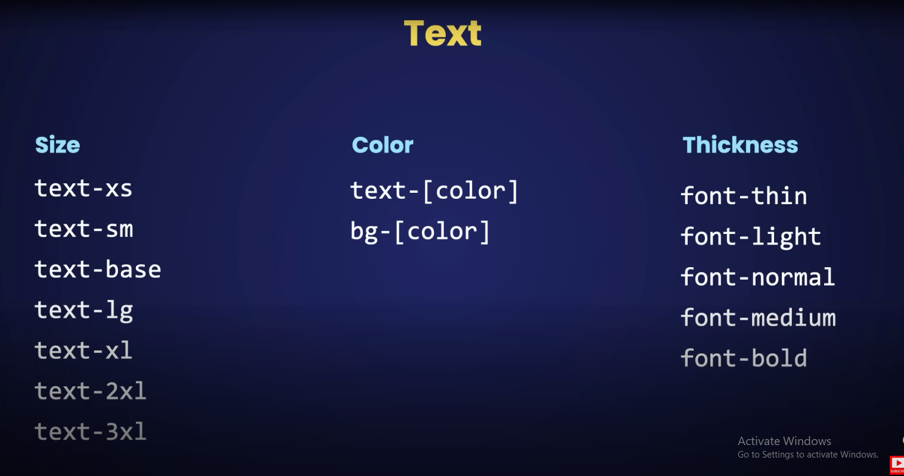
49:04
again we have a ton of classes for example for controlling the size we have text Dash XS which is extra small we
49:12
have text small text base which is like the regular size we have text large x-large 2x large and so on for applying
49:20
colors we have classes that start with text followed by a color so if you Google Tailwind color palette
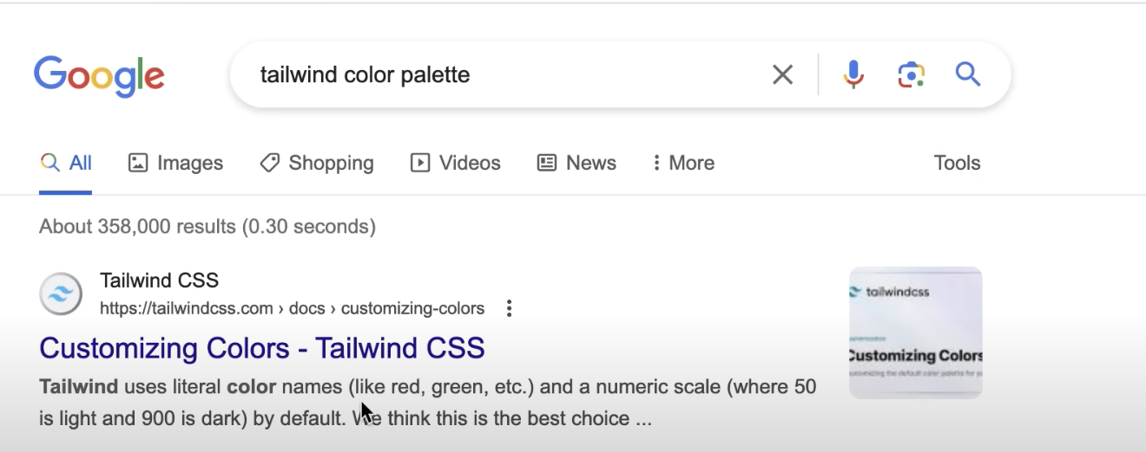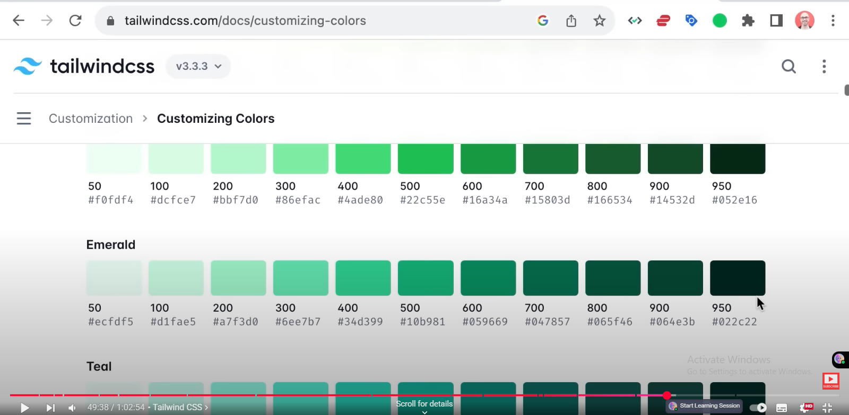
49:29
on this page you can see the default color palette that comes with Tailwind so we have all
49:36
these beautiful colors and for the most part we don't need to customize them they just look great as they are but you
49:43
can always customize these and use colors that are specific to your brand Now look for example for Sky we have
49:50
various shades of blue that start with 50 and go all the way to 950. the larger
49:56
the number the darker the color you will see an example of this later in this video now back to our slide we're
50:03
controlling the background color we have a bunch of classes that start with BG followed by a color code now for
50:10
controlling the thickness of font we have a bunch of classes like font thin font light normal medium bold and swap
50:18
that's the idea of Tailwind now there are a lot more classes in Tailwind that we can cover here but our Focus here in
50:25
this course is on nyxjs and not Tailwind I just want to show you the basics so you can learn the rest on your own so
50:31
let's say these classes in action and then I will explain why you may want to use Tailwind so back to our project
50:38
earlier we used the CSS module to style our product card let's see how we can
50:43
use Tailwind instead of a CSS module to style this component so in this file we don't need to import our
50:51
CSS module instead we can apply Tailwind utility classes right here now
50:59
in this lesson I'm going to use a different set of styles than the Styles we applied in our CSS module so you can
51:05
see more of Tailwind in action so we're going to give this some padding we type p dash that if you press control
51:12
and space you can see all the padding classes so we have p-0 which is
51:17
equivalent to padding zero we have padding one which is equivalent to 0.25
51:24
Ram or 4 pixels and as the number increases we get more padding so this
51:30
intellisense comes with the extension that we installed at the beginning of the course so let's give this a padding
51:36
of five a vertical margin of 5 now I want to give it a background color
51:42
so we type BG Dash that look again in intellisense we can see all the colors
51:49
I'm going to go with Sky Dash 400. now to make the text white here we apply
51:56
text Dash White we can make it large so here we use text Excel or 2XL 3XL and
52:05
so on again on the right side you can see the actual size that is applied so for text Excel font size is 1.25 Ram or
52:14
20 pixels now here's a part that gets interesting here we have sudo selectors like hover
52:21
and with this we can apply Styles when we hover over this box or this div so we
52:27
can change the background color to BG sky 600 or 500 to make it slightly darker
52:35
now back to the browser here's our div if we hover over it you can see the color changes
52:41
so this is how we style our applications with Tailwind now the selling point of Tailwind is that we can start our
52:47
components right here in our component file we don't have to juggle back and forth between a CSS file and a component
52:54
file everything is in one place now some people argue that this violates the separation of concerns principle but I
53:02
have to disagree with that because the whole idea of separation of concerns is organize our code into distinct sections
53:09
or modules each having a separate concern if you follow this principle
53:14
we'll have more opportunities for reuse but in this case this react component
53:19
itself is a module and defines the ReUse boundary so what we have inside this
53:25
boundary is purely implementation detail we can have markup with JavaScript and
53:30
style all next to each other what is inside is irrelevant to the outside world as long as this component or this
53:37
module is reusable that's just what I think if you disagree or don't like using Tailwind that's totally fine but
53:44
again if you want to expand your job opportunities I highly encourage you to learn Tailwind because it's in high
53:49
demand these days but there is one more benefit to using tailwind and this is the reason I personally love Tailwind
53:55
with Tailwind when we build our application our final CSS bundle will
54:00
only have the utility classes that we have used in our markup so if tomorrow we delete this div none of these classes
54:08
will be in our final CSS bundle unless we have used them somewhere else so with
54:13
Tailwind we don't have to remember to clean up as we change or delete our components with CSS modules if we delete
54:21
this component we have to remember to delete this CSS file as well or if we
54:26
change the structure here we might still have unused classes in our CSS module so we have to remember to come back and
54:32
clean up so that's the selling point that convinced me to start using Tailwind but on the flip side I don't
54:39
like that over time as our marker gets complex will have a lot of these classes and the code is kind of hard to read but
54:46
it's just a matter of getting used to it it's not terribly bad but it's something that puts some people off early on but
54:52

over time I think the benefits outweigh the downside
DaisyUI
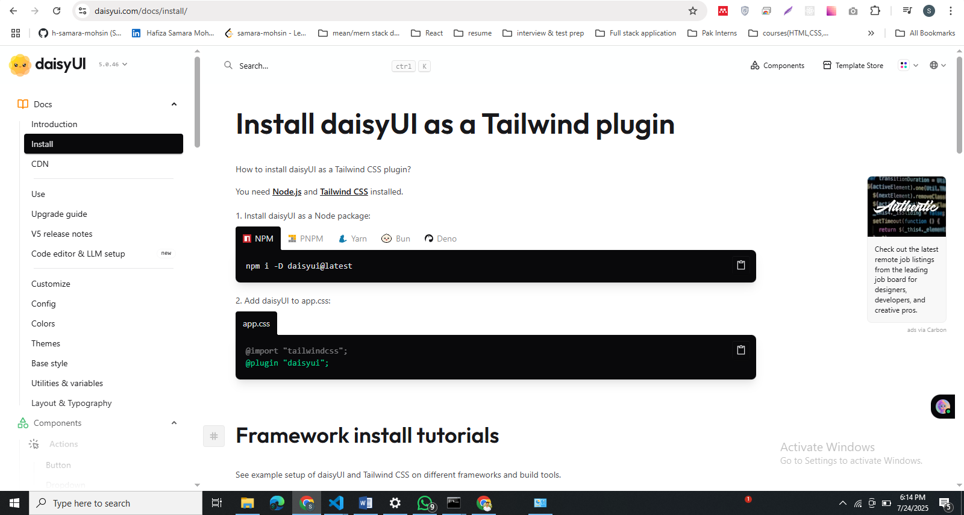
55:02
all right now let's talk about Daisy UI Daisy UI is a very popular component
55:07
library for Tailwind it's kind of like bootstrap for Tailwind so if you head over to daisyui.com you can see all
55:15
these components for example we have accordions alerts
55:20
we have breadcrumbs buttons cards Carousel chat Bubbles and so on very
55:27
very useful it's very easy to use so let's go to the installation page
55:33
first we have to install Daisy as a development dependency so I'm going
55:39
to copy this line now back in vs code I've opened my terminal window you can open it from terminal new terminal
55:47
now let's paste that good next
55:53
we should add daisy as one of the plugins of Tailwind so we should go to
55:59
Tailwind configuration file in the root of our project so that is right here
56:07
currently there are no plugins so let's copy this line and
56:13
paste it here there's literally all we have to do now
56:18
let's see how we can use these components so as an example
56:24
we're going to look at the button component so here we have a bunch of classes like
56:30
BTN BTN neutral BTN primary secondary and so on exactly like bootstrap under
56:36
the hood these classes use Tailwind so instead of us manually combining a bunch
56:41
of small Tailwind classes to create a button we can just use the button that comes with Daisy and of course we can
56:49
always customize these buttons okay so to create a button look we should have an example down here
56:55
there you go this is just a basic button we also have neutral primary secondary
57:00
and so on so back to our code less style this component that we
57:07
created earlier add to cart so here we have a button we set class name to BTN BTN Dash
57:15
primary we don't have to import anything in this file okay now back to the homepage here's what we get let's remove
57:22
this blue background because it looks kind of odd so we're going to go back to
57:28
product card the TSX and I'm going to remove all these
57:33
Tailwind classes okay so here's what we are left with now in
57:39
DayZ we have the concept of themes for example if you look at this page
57:45
themes you can see all the available themes now in this lesson I'm going to use a
57:53
theme called winter and you can always preview these themes so on the top you
57:58
can select them and see what your application looks like here's the dark mode here we have the cupcake theme and
58:04
so on now to use a theme there are two steps we have to follow first we have to go in Tailwind
58:11
configuration file and add this section for days UI so here we activate the
58:16
themes we want to use so let's copy this section
58:22
and go back to Tailwind config.ts right after plugins we paste this so we
58:29
have Daisy UI we have themes I don't want to use any of these I only want to use
58:34
the winter theme the second step is to apply this theme on our HTML element so
58:41
back in the documentation look here we have a data attribute for specifying the theme to do that we have to go to our
58:48
layout file because this is where we have our HTML element so we set data Dash theme to
58:56
Winter now back to our home page our button looks blue beautiful now let's go to the
59:02
users page and put these users inside a table so let's
59:07
go to the users page and replace this unordered list with a table so we
59:15
select this and press command and D on Mac or Ctrl ND on Windows to activate
59:21
multiple cursors now we can change these two elements in one go so we change it
59:26
to a table then we press escape to deactivate multiple cursors
59:32
now inside this table we want to have a t head inside the T head we want to have a TR and inside the TR we want to have
59:39
two th elements let's press tab here's our markup beautiful now here we want to
59:46
have two columns the first one is username the second is user email
59:51
now after the t-hat element we should add a tea body then we move mapping our users inside T
59:59
body and replace Li with TR so once again we press command and D on Mac or
1:00:06
Ctrl and D on Windows to change both these elements in one go so let's change
1:00:11
it to tr the inside is TR we want to have two th
1:00:17
elements so th times two let me put it on a separate line
1:00:23
good in the first th we want to render user.name in the second moon render
1:00:30
user dot email and currently we don't have email in the interface that we
1:00:35
defined for our users that is why we get a compilation error so this is another benefit of using typescript the
1:00:42
typescript compiler tells us about these issues before we run or deploy our application we can catch these errors at
1:00:49
compile time or even while coding so up here we have the user interface let's add an
1:00:57
email property of type string now the error goes away lovely so back to
1:01:04
the browser here's what we get now let's apply a couple of classes from Daisy to
1:01:09
make this table look a little bit nicer so back to our code here's our table
1:01:15
we set class name to table and table Dash bordered
1:01:21
and of course you can find these in the documentation for the table component in DayZ UI
1:01:27
okay this is much better now I made a mistake earlier when rendering these
1:01:33
rows I used the th element that is why they appear as bold but we
1:01:39
should use th only as the column of our tables so let's change all of these th elements
1:01:45
to TD once again we select one of them and we press command and D to select
1:01:51
more of them so now we have four cursors let's change all of them to t d
1:01:58
okay here's what we get now we no longer need the timestamp so let's remove it
1:02:03
from here as well good so we're done for now in the next
1:02:08
section we're going to talk about routing and navigation in more detail hey guys I hope you've been having fun
1:02:15
watching this tutorial I just wanted to mention that this tutorial is the first hour of my complete next JS course so
1:02:23
after you finish this if you want to learn more I highly recommend you to enter on the full course because it's
1:02:28
much faster and easier than jumping between a bunch of random disconnected tutorials here on YouTube the full
1:02:35
course is 5 hours long and teaches you everything you need to build full stack applications with nexjs it also comes
1:02:42
with a certificate of completion and a 30-day money-back guarantee so if you're not happy ask for a full refund you get
1:02:49
all your money back no questions asked in case you are interested the link is below this video

